Electronic Instrumentation and optoelectronics LAB

LAB exercises

LAB1-1.- Connect the function generator, and select a 2 Vpp, 10 Hz sinus signal. Connect the output of the function generator to the oscilloscope and set the controls to see 1 signal cycle. You must see the signal amplitude as big as possible in the oscilloscope screen. The oscilloscope must be coupled in DC and the trigger must be in the AUTO position. Do not use the Auto- scale button!!

Draw the obtained waveform, and write down the control's position.

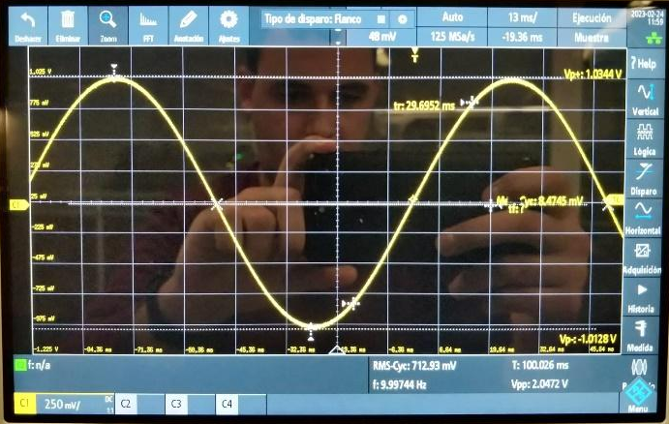

Vertical amplifier: 250mV/div

Timebase: 13ms/div

DC Coupling

LAB1-2.- Change the oscilloscope coupling to AC.
Draw the obtained waveform, and write down the control's position.

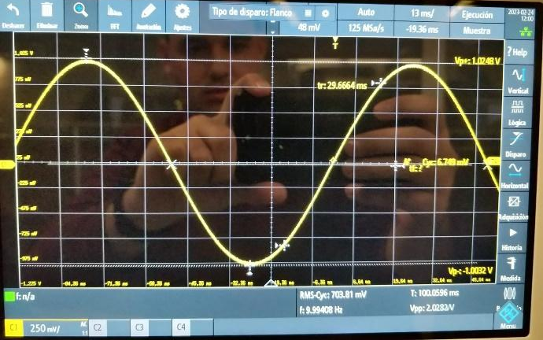

Vertical amplifier: 250mV/div

Timebase: 13ms/div

AC coupling

Is there any difference between the two waveforms? What is the reason?

No, as shown in the two images, there are no significant differences due to the fact that the selected signal is a sinusoidal function and has no harmonics. As a result, the high pass filter does not affect to the signal, because in AC and DC the signal has the same waveform.

LAB1-3.- Now, change the waveform to an square wave and maintain the oscilloscope settings.

Draw the obtained waveform, and write down the control's position.

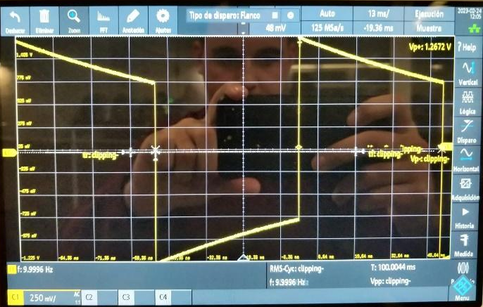

Vertical amplifier: 250mV/div

Timebase: 13ms/div

AC coupling

LAB1-4.- Change the oscilloscope coupling to DC.
Draw the obtained waveform, and write down the control's position.

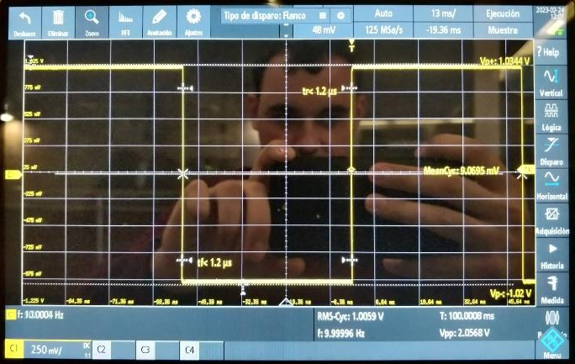

Vertical amplifier: 250mV/div

Timebase: 13ms/div

DC Coupling

Explain the reason of the difference between the two measured waveforms.

The capacitor takes time to charge and discharge in AC coupling, so that, if we add the two signals, the result in the first image. But this does not happen with the DC coupling because the capacitor is like an open circuit and we just have the square signal.
In the frequency domain, this difference is explained by due to the fact that the square waveform has periodic harmonics, so the high pass filter captures some of the harmonics.

LAB1-5.- Measure the waveform rise-time. Compare the obtained value whit that given in the instrument specifications. Are there similar? If not, explain which other factors contribute to the measured rise-time.

The value obtained in the oscilloscope viewing one rise in the screen is 8,74ns. This value is smaller than the one calculated, the rise time is supposed to be smaller than 17.75. The obtained value therefore
$t_{rise}=\sqrt{{t_{osc}}^{2}+{t_{low-pass filter}}^{2}+t_{wave gen}^{2}}$=$\sqrt{5^{2}ns^{ }+(2.2ns ·5ns)^{2}+13^{2}ns}=17.75ns$
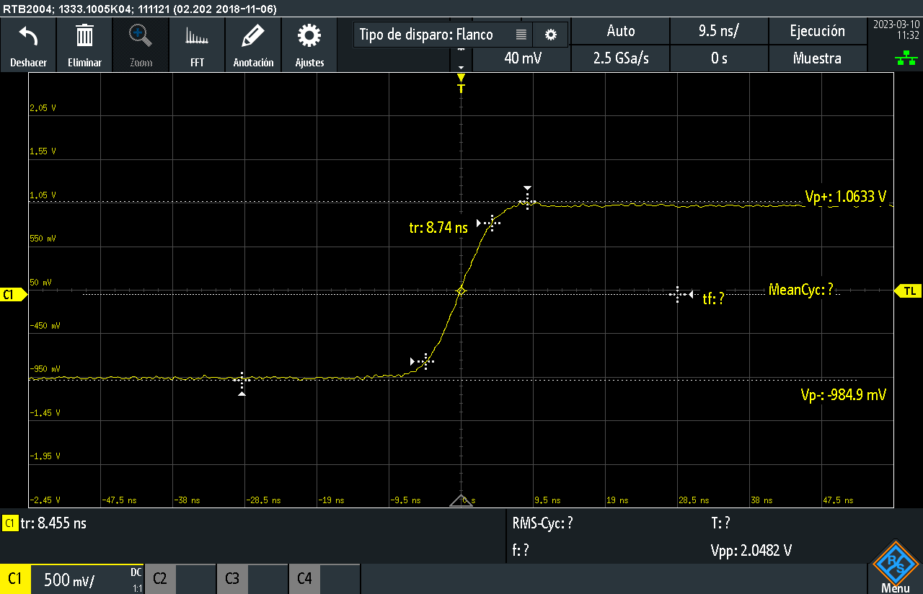
8.74ns<17.75ns
LAB1-6.- Connect the power supply and set it to obtain an output of ± 7V. Measure these voltages with the Digital multimeter. Draw the measurement set-up and explain how the measurement has been performed.

In order to take the measurements, we have connected the power supply to the Digital multimeter, first with the positive voltage, and then with the negative voltage.

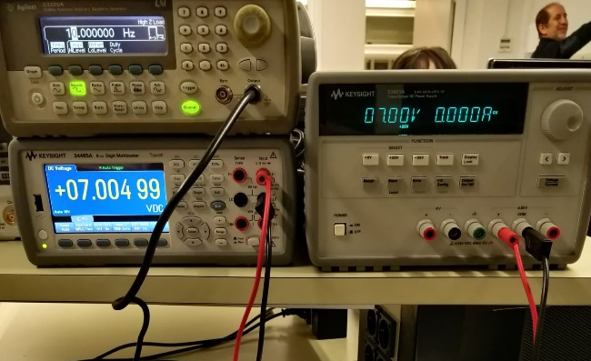 | 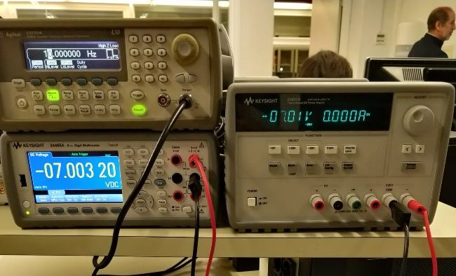

LAB1-7.- Set the waveform generator to obtain a square wave with an amplitude of 3 Vpp and a mean value of 1.5 V. Measure this wave with the oscilloscope to verify it. Explain clearly the oscilloscope and waveform generator settings.

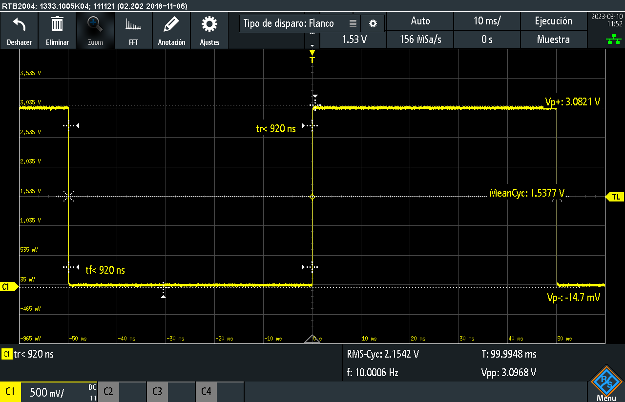

The waveform generator settings
offset level = 1.5 V DC
Square wave selection
Amplitude = 3V
Checking the waveform in the oscilloscope we see that the mean value is 1.533V and that the max value is 3.0821V. So, we can say that the result is correct and that the difference observed in the mean can be due to the measurement uncertainty and the coaxial cable.
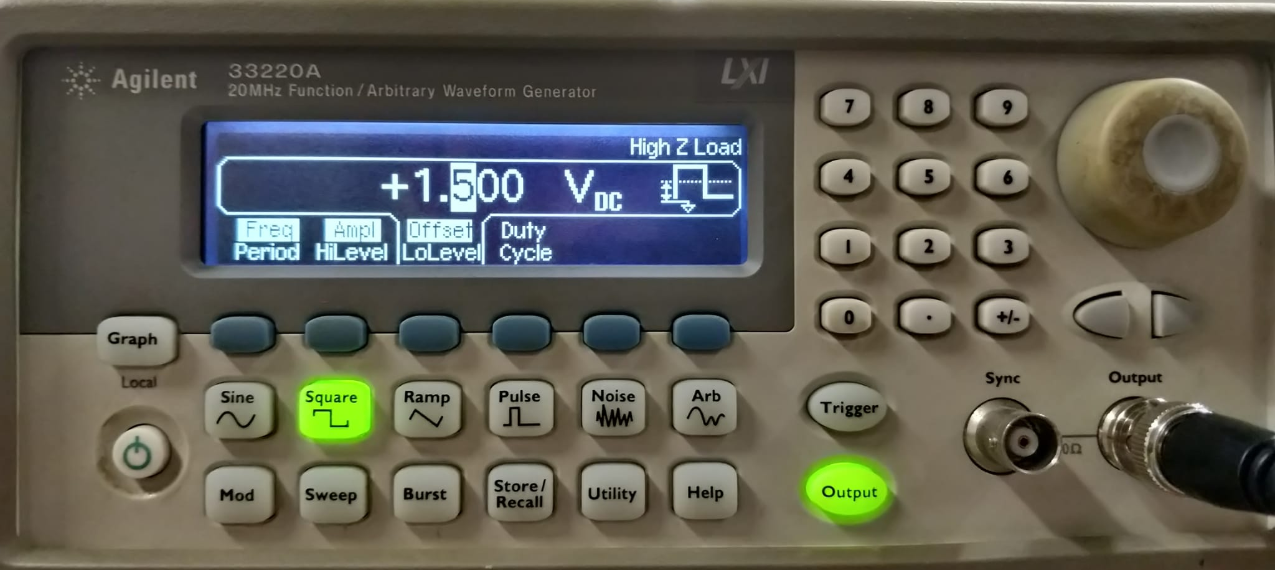

LAB1-8.- Connect the multimeter to the waveform generator and measure the root mean square value of the voltage. Explain how the measurement has been performed.

To measure the square value of the voltage we have set the multimeter in AC mode, and the average given is 1.461V.
The supposed value is 1.5 but as we are at 10Hz there is more uncertainty.
The measure has been done connecting the coaxial cable from the waveform generator to the multimeter and setting it to AC mode.
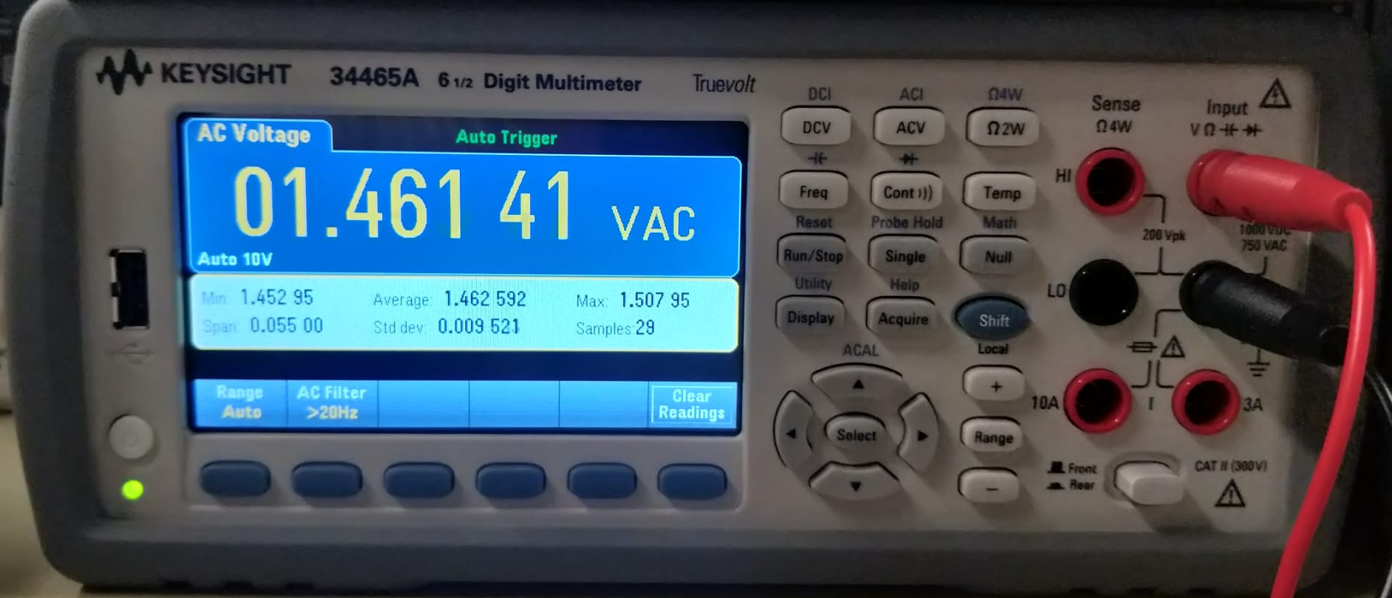

LAB1-9.- Calculate the root mean square value of the previous waveform. Coincides with the measured one? If not, explain why.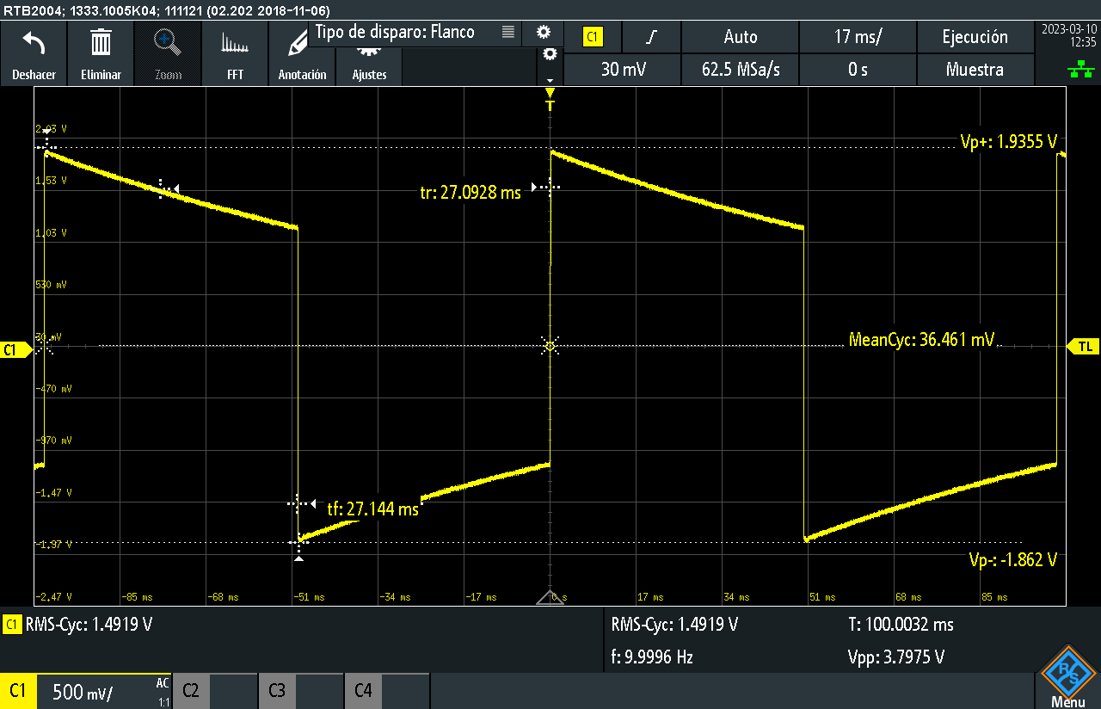

Setting the multimeter to AC mode the result obtained is 1.4919.
This value corresponds to the one calculated, that is $\frac{\sqrt{3^{2}+0^{2}}}{2}=1.5$

